**The Like, Share, and Follow Formula: Marketing in the Age of Social Media**

Social media has become the ultimate marketing playground, a vibrant landscape teeming with potential customers. Marketers, armed with the power of likes, shares, and comments, have transformed the way brands connect with their audience. Imagine a clothing company hosting a social media contest where users submit photos sporting their favorite outfits, instantly generating brand awareness and user-created content. Social media fosters a two-way conversation, allowing brands to humanize themselves and engage with their audience in a more personal way.

The beauty of social media marketing lies in its targeted reach. Marketers can leverage algorithms and data to tailor their message to specific demographics and interests. Gone are the days of blanket advertising – social media allows for laser-focused campaigns that resonate with the right audience at the right time. Imagine a sports drink brand partnering with fitness influencers to create workout videos featuring their product, directly reaching a health-conscious audience actively seeking fitness content. Social media cuts through the noise, delivering targeted messages that convert into brand loyalty and sales.

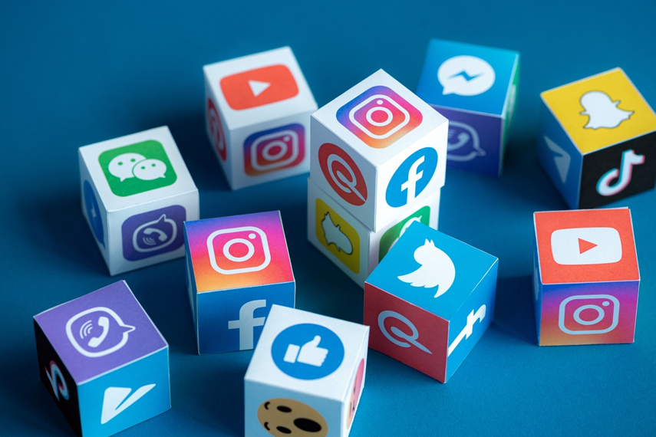

However, navigating the ever-evolving social media landscape requires constant adaptation. Marketers must stay ahead of the curve, embracing new platforms, features, and trends. A rigid strategy that worked yesterday might fall flat today. The key lies in creating engaging content, fostering genuine interactions, and being responsive to audience feedback. By staying agile and creative, marketers can leverage the power of social media to build brand communities, drive conversions, and ensure their message stays relevant in the ever-scrolling social media feed.